**Qais Nimer**

1- WORD DOCUMENT:

A- Define Scope: Recorded Courses System.

B- Mandatory Objects: Admins, Courses, Instructors

C- Software Type: Customized Software

1) Admin:

- Should have an existing account (seeding data)

- Login to the system

- Add Instructor by (Full Name, Phone Number, email, password, profile image, bio)

- Explore instructors by (Email, profile image, bio)

- Explore specific instructor by (Email, profile image, bio)

- Activate/Deactivate specific instructor

- Edit instructors by (Full Name, Phone Number, email, bio)

- Add Learners by (Full Name, email, password, profile image, bio)

- Explore learners by (Email, profile image, bio)

- Explore specific learner by (Email, profile image, bio)

- Activate/Deactivate specific Learner

- Edit Learner by (email, bio)

- Add Course by (title, description, category, level, price, discount, Total Duration).

- Explore All Courses by (title, description, category, level, price, discount,   
 Total Duration).

- Explore (Filter) Specific course by (title, category, level, price, discount,   
 Total Duration).

- Explore Lessons by (title, Duration, VideoType, IsCompleted)

- Search on specific course by (Title)

- Activate/Deactivate specific Course

- Edit Course by (title, description, category, level, price, discount, Total Duration).

- Explore Enrollments by (EnrollFlag)

- EXPLORE Course Reviews by (Message)

- EXPLORE Course Ratings by (Rate Amount)

- Explore and Tracking Progress by (Tracker)

- Explore Bookmarked Favorite Courses for each learner by (FavCourseFlag)

- Add Categories (Category Type, Category Item)

- Explore all Categories (Category Types, Category Items)

- Activate/Deactivate specific Category

- Edit Category

- Explore Price by (Price Amount)

-Add PricePlans by (Plans)

- Explore all PricePlans by (Plans)

- Edit PricePlans by (Plans)

- Deactivate/ Activate PricePlans

- Generate Analytics reports on revenue

- Generate Analytics reports on Enrollments

- Generate Analytics reports on Instructors Performances (Enrollments, Reviews,   
 Ratings).

-Can Logout

2) Instructor:

- Can Login

- Add Course by (title, description, category, level, price, discount, Total Duration).

- Explore All Courses by (title, description, category, level, price, discount,  
 Total Duration).

- Explore Specific course by (title, description, category, level, price, discount,   
 Total Duration).

- Add Lessons by (title, Duration, VideoType, IsCompleted)

- Explore Lessons by (title, Duration, VideoType, IsCompleted)

- Set Price by (Price Amount)

- EXPLORE Course Enrollments (EnrollFlag)

- EXPLORE Course Reviews by (Message)

- EXPLORE Course Ratings by (Rate Amount)

- Can Logout

3) Learners

- Can Login

- Explore All Courses by (title, description, category, level, price, discount,   
 Total Duration).

- Explore (Filter) Specific course by (title, category, level, price, discount,   
 Total Duration).

- Search on specific course (Title)

- Enroll to specific Course by (EnrollFlag)

- Explore Lessons by (title, Duration, VideoType, IsCompleted)

- Track Progress by (Tracker)

- Bookmark Favorite Courses by (FavCourseFlag)

- Can Rate Course by (RateAmount)

- Review Courses by (Message)

- Explore Rating by (Rate Amount)

- Explore Price by (Price Amount)

- Can logout

D-Summarize System Objects

- shared attributes (id, createdby, updatedby, isActive, updatedate, creationdate)

- Admin: Full Name, Email, Password.

- Instructor: Full Name, Phone Number, email, password, profile image, bio.

- Learners: Full Name, email, password, profile image, bio.

- Courses: title, description, category, level, price, discount,   
 Total Duration

- Lessons: title, Duration, VideoType, IsCompleted

- Category: Category type, Category items

- Reviews: Message

- Rating: RateAmount

- Price: Price Amount

- Favorite Course: FavCourseFlag

- Track Progress: Tracker

- Enroll: EnrollFlag

- Search Courses: Title

- Filter Courses: title, category, level, price, discount, Total Duration

- PricePlans: Plans.

E- Generalization and Specialization:   
 - Generalization:

- Parent: Shared Properties

- Parent Entities:

- Review, Rating => Rate

- Price, PricePlans => Price

- Specialization:

- Users: Instructor, Learner

- Rate: Review, Rating

- Price: Price, PricePlans

F- Define Relationships:

A- Inheritance:

Relation between Shared Properties as Parent and the parent entities as children

(Id, CreationBy, CreationDate, UpdatedBy, UpdatedDate, isActive)

Admins

User

Courses

Lessons

Category

Rate

Price

Favorite Courses

Track Progress

Enroll

Search Courses

Filter Courses

B- Composition:

Admins

Instructor: (1-M) Courses, (1-M) Lessons, (1-M) Rates

Learner: (M-M) Courses, (M-M) Lessons, (M-M) Rates,   
 (M-M) FavoriteCourses, (M-M) TrackProgress, (M-M) Enroll,  
 (M-M) SearchCourses, (M-M) FilterCourses

Courses: (1-M) Lessons, (M-M) Categories, (1-M) Rates, (1-M) Prices,   
 (M-M) FavoriteCourses, (M-M) Enroll.

Lessons: (1-M) TrackProgress

Category:

Rate

Price

Favorite Courses

Enroll

- Association, Composition, Aggregation:

- instructor + Course = Composition

- instructor + Lessons = Composition

- instructor + Rates = Association

______________________________

- Learner+ Course= Aggregation

- Learner+ Lessons= Aggregation

- Learner+ Rates= Composition

- Learner+ FavoriteCourses= Composition

- Learner+ TrackProgress =Composition

- Learner+ Enroll =Composition

- Learner+ SearchCourses = Association

- Learner+ FilterCourses = Association

__________________________________

- Course+ Lessons = Aggregation

- Course+ Categories = Aggregation

- Course+ Rates = Composition

- Course+ Price = Composition

- Course+ FavoriteCourses = Composition

- Course+ Enroll= Composition

____________________________________

- Lessons + TrackProgress= Aggregation

2) Implement ER- Diagram

- Weak Entities:

- Single Dependence: Course, Lesson

- Multiple Dependence: Rates, FavoriteCourses, TrackProgress, Enroll, Price

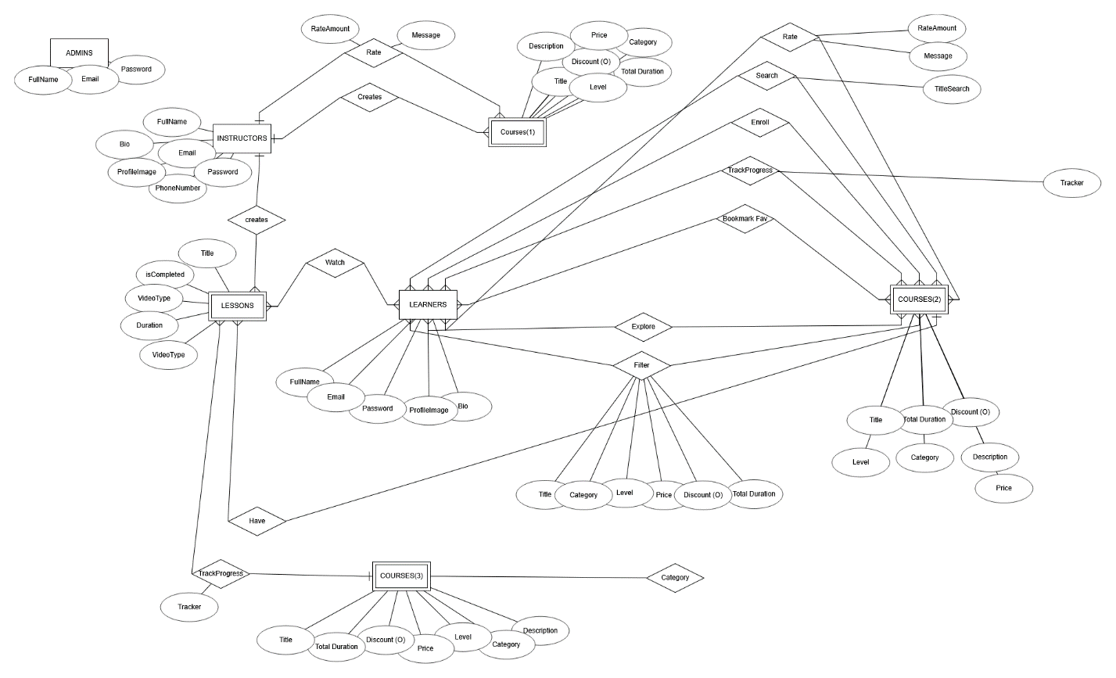

3) Normalization Pattern:

- (Actors, Objects, Lookups Attributes)

- LOOKUPS:

1) Categories (Programming, Marketing, Business, Mathematical, etc…)

2) level: Beginner, intermediate, advanced

3) Video Type: MP4, Live, etc…

4) PricePlans: Free, Monthly Subscription, One Time Payment

5) Rate Amount: 1-5 only

4) Fill testing data

5) implement (stored procedure/ functions/ view / trigger/ Job):

Database Views

1. **Active Courses View**:

o Create a view to display all active courses, including category, instructor name, and total

enrollments.

2. **Learner Progress View**:

o Implement a view to show progress for all learners, including course details and

completion percentages.

3. **Revenue Summary View**:

o Create a view summarizing revenue generated by each course, instructor, and overall

platform.

Stored Procedures

1. **Enroll Learner in Course**:

o Write a stored procedure to handle learner enrollments, ensuring the course exists and

the learner has an active account.

2. **Add a New Course**:

o Implement a stored procedure for instructors to add courses, including lessons and

metadata.

3. **Generate Revenue Report**:

o Create a stored procedure to generate a report of total revenue per course and

instructor within a specific timeframe.

4. **Manage Discounts**:

o Write a stored procedure to apply or update discounts on courses based on promotional

campaigns.

6) Test the required business case/ requirement

1. **Retrieve Courses by Category**:

o Write a query to fetch all courses within a selected category, including title, price, and

ratings.

2. **Search Courses**:

o Implement a query to search courses by keyword in the title or description.

3. **Track Learner Progress**:

o Create a query to retrieve the progress of a learner in a specific course, including

completed lessons and remaining lessons.

4. **Top-Rated Courses**:

o Write a query to identify the top-rated courses based on average ratings and enrollment

numbers.